VILNIAUS UNIVERSITETAS
MATEMATIKOS IR INFORMATIKOS FAKULTETAS
KOMPIUTERIJOS KATEDRA



Programų sistemų archirektūros darbas

Sports site for NGBLA
(National German Basketball League for Amateurs)

Atliko: 3 kurso, 4 grupės studentai:
Rokas Malukas
Rokas Ščepanovas

Darbo vadovas:
Andrius Vytautas Misiukas Misiūnas

Vilnius
2017
Turinys

1.Goal 3
2.Iterations 4
2.1.First iteration 4
2.2.Second iteration 4
2.3.Third iteration 5
2.4.Fourth Iteration 5
3.Instructions to run the project 6
3.1.Technologies needed 6
3.2.Instructions to set up the environment on Linux OS 6
4.Project diagrams 7
4.1.Service actions diagram 7
4.2.Database structure diagram 9
4.3.Use case diagram 11

Goal
Our main goal of this project is to create a sports fan page for National German Basketball League (NGBLA). In the process of creating the web page four iterations of at least 4 functionalities each must be implemented.

Iterations

First iteration

The first iteration of our project included the following functionalities:
- Ability for the superuser to create a post in the news feed
- Ability for the superuser to edit an already created post in the news feed
- Ability for the superuser to remove an existing post in the news feed
- A view where any user can read the news feed where all posts are listed
- A detailed view of post from news feed that any user can browse

Second iteration

The second iteration of our project was focusing on the forum part of our website with the following functionalities:
- Ability for a registered user to create a forum post
- Ability for the superuser to edit an existing forum post
- Ability for the superuser to remove a forum post
- Display the list of forum posts and ability to view them in detailed

Third iteration

The third iteration included functionalities as follows:
- Ability for registered users to create comments in news feed and forum
- Ability for the superuser to remove any comments
- Ability for the superuser to submit match details such as date, score and teams
- Ability for the superuser to submit player details such as name, height, team

Fourth Iteration

The final iteration of our project included the following functionalities:
- Ability to sort news in feed by their favorite team
- Ability for the superuser to submit scores
- Ability for the superuser to add, edit and delete player statistics
- Implementation of front end part of the web page
- Registration, logging in and logging out

Instructions to run the project

Technologies needed
Ir order to run the project the following must be installed on the machine:
- Python3
- Python pip
- Python virtual environment
- Various pip packages including Django framework

Instructions to set up the environment on Linux OS
First of all, Python is needed to be installed on the machine. By default, it is installed in the Linux operating system.
After making sure that Python is installed, a virtual environment must be set up. A virtual environment to configure settings on different projects. In order to set up the environment the following line should be entered in the terminal:
python3 -m venv virtual-environment-name
This will create a folder with needed files inside it. To enter the environment enter this line:
source virtual-environment-name/bin/activate
Then program named pip is needed for package management. It is also included by default with Python. In order to install required dependencies this line should be executed inside the sports-site/ folder:
pip install -r requirements.txt
This will install all the packages named in the requirements.txt file inside project folder. After this to start the web page on localhost the following command must be entered inside sports-site/ folder where manage.py file is apparent:
python manage.py runserver
This will power on the server and web page will be accessible. The link to the web page will be given in the terminal.

Project diagrams

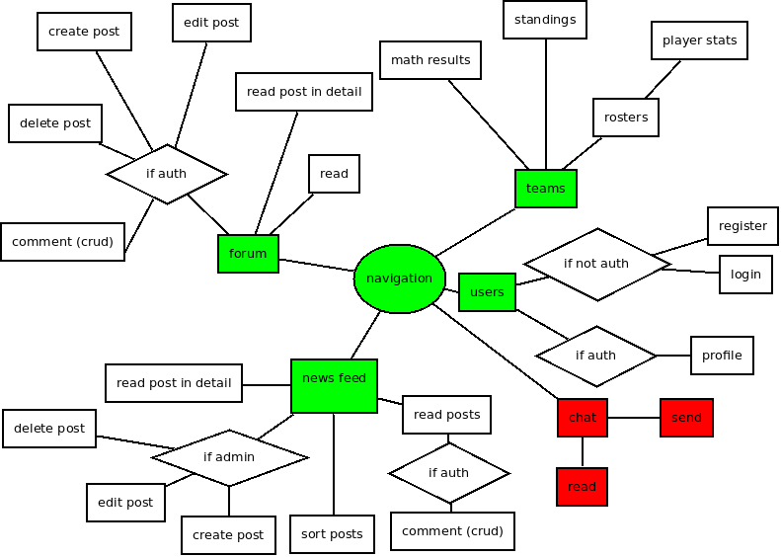
Service actions diagram

The above diagram displays the functionalities that our project has. Green nodes resemble functionalities that have been fully developed. Red color stands for functionalities that our team decided to not implement. We decided that chat functionality was unnecessary because people already had a few means of expressing their opinions through comments in the news feed and forum posts.
Here is the list of functionalities fully implemented:
Forum for teams fans (crud functions);
- read post;
- create post;
- edit post;
- delete;
- comment;

Login/register forms;
- create user;
- authenticate user;

Teams statistics;
- roster;
- standings;
- results;
- players stats;

Schedule;
- upcoming matches;
- history;

News feed;
- read post;
- create post;
- edit post;
- delete;
- comment;
- sort by team;

Database structure diagram
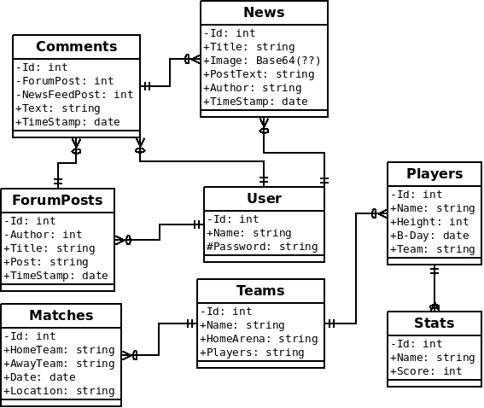

The above diagram displays the database structure, including the information held and connections between entities. Initially chat entity was in the structure connected to the Players table but was removed due to our decision to not implement chat functionality.
Listed tables:
- Users;
  - Name;
  - Password;
- News;
  - Title;
  - Image;
  - PostText;
  - Author(User.Id);
- Players;
  - Name;
  - Height;
  - B-Day;
  - Team(Team.Name);
- Stats;
  - Player(Player.id);
  - Player(Player.Name);
  - Score;
- Teams;
  - Name;
  - HomeArena;
  - Players(Player.Name);
- Matches;
  - HomeTeam(Team.Name);
  - AwayTeam(Team.Name);
  - Date;
  - Location(Team.HomeArena);
- ForumPosts
  - Author(User.id);
  - Title;
  - Post;
  - TimeStamp;

- Comments;
  - ForumPost(ForumPost.Id);
  - NewsFeedPost(News.Id);
  - Text;
  - TimeStamp;

Use case diagram
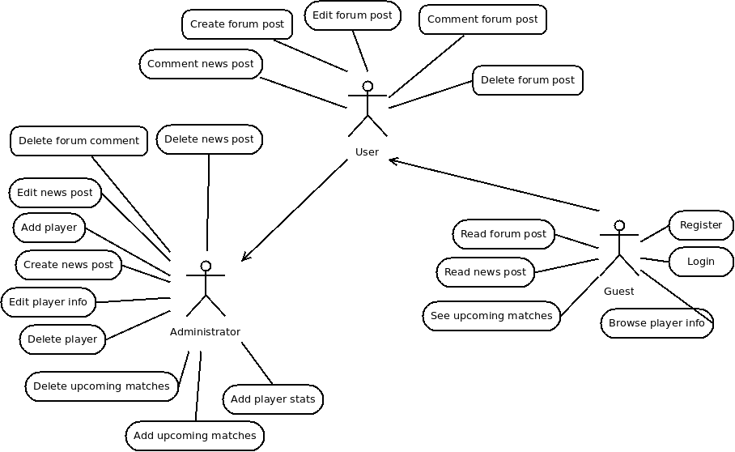

Above is the use case diagram which demonstrates which users have which privileges. Unregistered user (Guest) has the fewest privileges. A registered user inherits all functionalities that a guest is allowed to use. Also a registered user gains access to create comments in the news feed and forum as well as create new forum posts. Administrator inherits both Guest's and User's accessibilities as well as gains access to submit news feed posts, team, matches and player information.
Initially Guest was able to read chat's messages and User had access to send new messages in the chat. Also Administrator was mean to be able to manage chat messaged by being enabled to remove them. But since we removed the chat from our project plan the use case diagram was updated with the removal of the mentioned functionalities.

